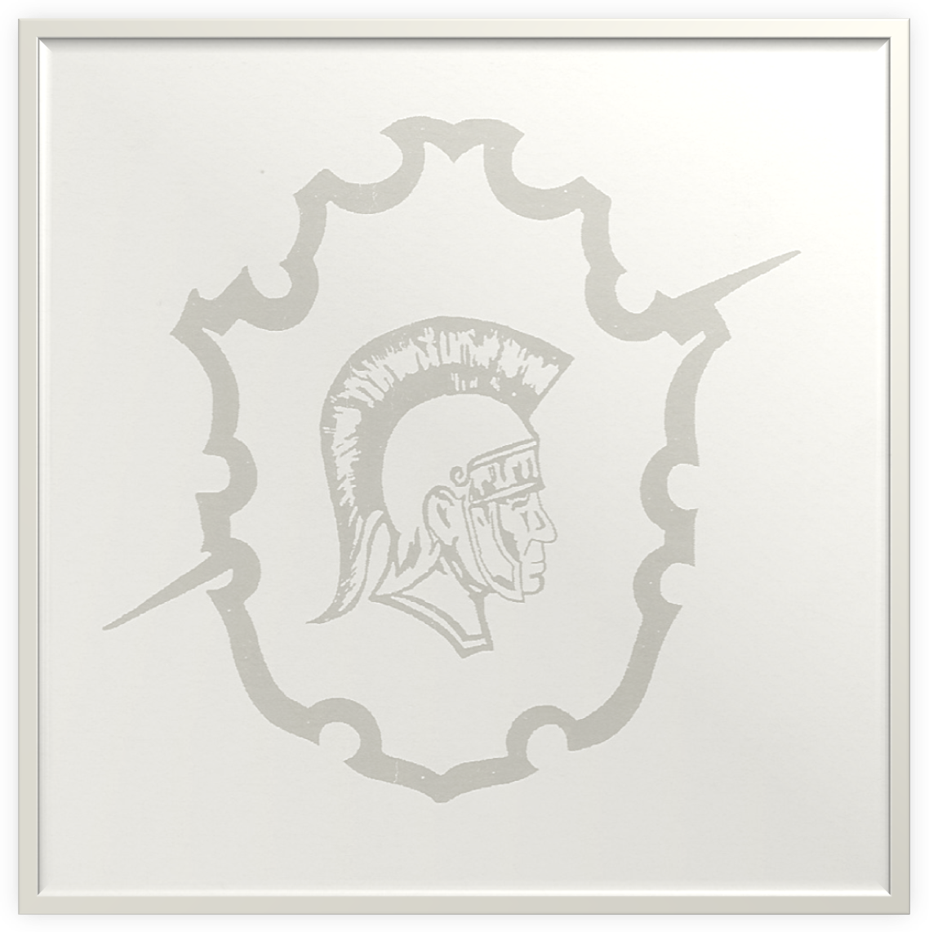

900 N. Martin Luther King Ave.
Oklahoma City, OK 73117
(405) 587-4200

BOYS AND GIRLS CROSS COUNTRY SCHEDULE

August 27th--- Capitol High School Invitational @ Capitol High School

September 8th--- Panther Open Run XC Meet (PCN) @ Woodson Park

September 18th---- OK Runner Classic (Norman)@ Irving Middle School

September 29th---- ALL—CITY XC Meet @ Woodson Park

October 1st----- Bethany Bronchos XC Meet @ Eldon Lyon Park

October 17th ------Regionals (TBA)

October 24th-------State Championship @ Shawnee, Oklahoma

